PRATHIKSHA V
1VI23CD035

TABLEAU ASSIGNMENT – QUESTION 12
CATEGORY-WISE SALES REPORT
Dataset Used: Superstore_USA
Tool Used: Tableau Desktop / Public
Visualization Created: Donut Chart – Total Sales by Product Category
Objective:
To analyze the Sales distribution across different Product Categories in the Superstore data and visualize it using a Donut Chart (Pie chart with a hole in the center).
Steps Implemented:
- Data Import
- Opened Tableau Desktop.
- Connected to the Excel file Superstore_USA.
- Verified that fields such as Sales and Product Category were correctly detected.
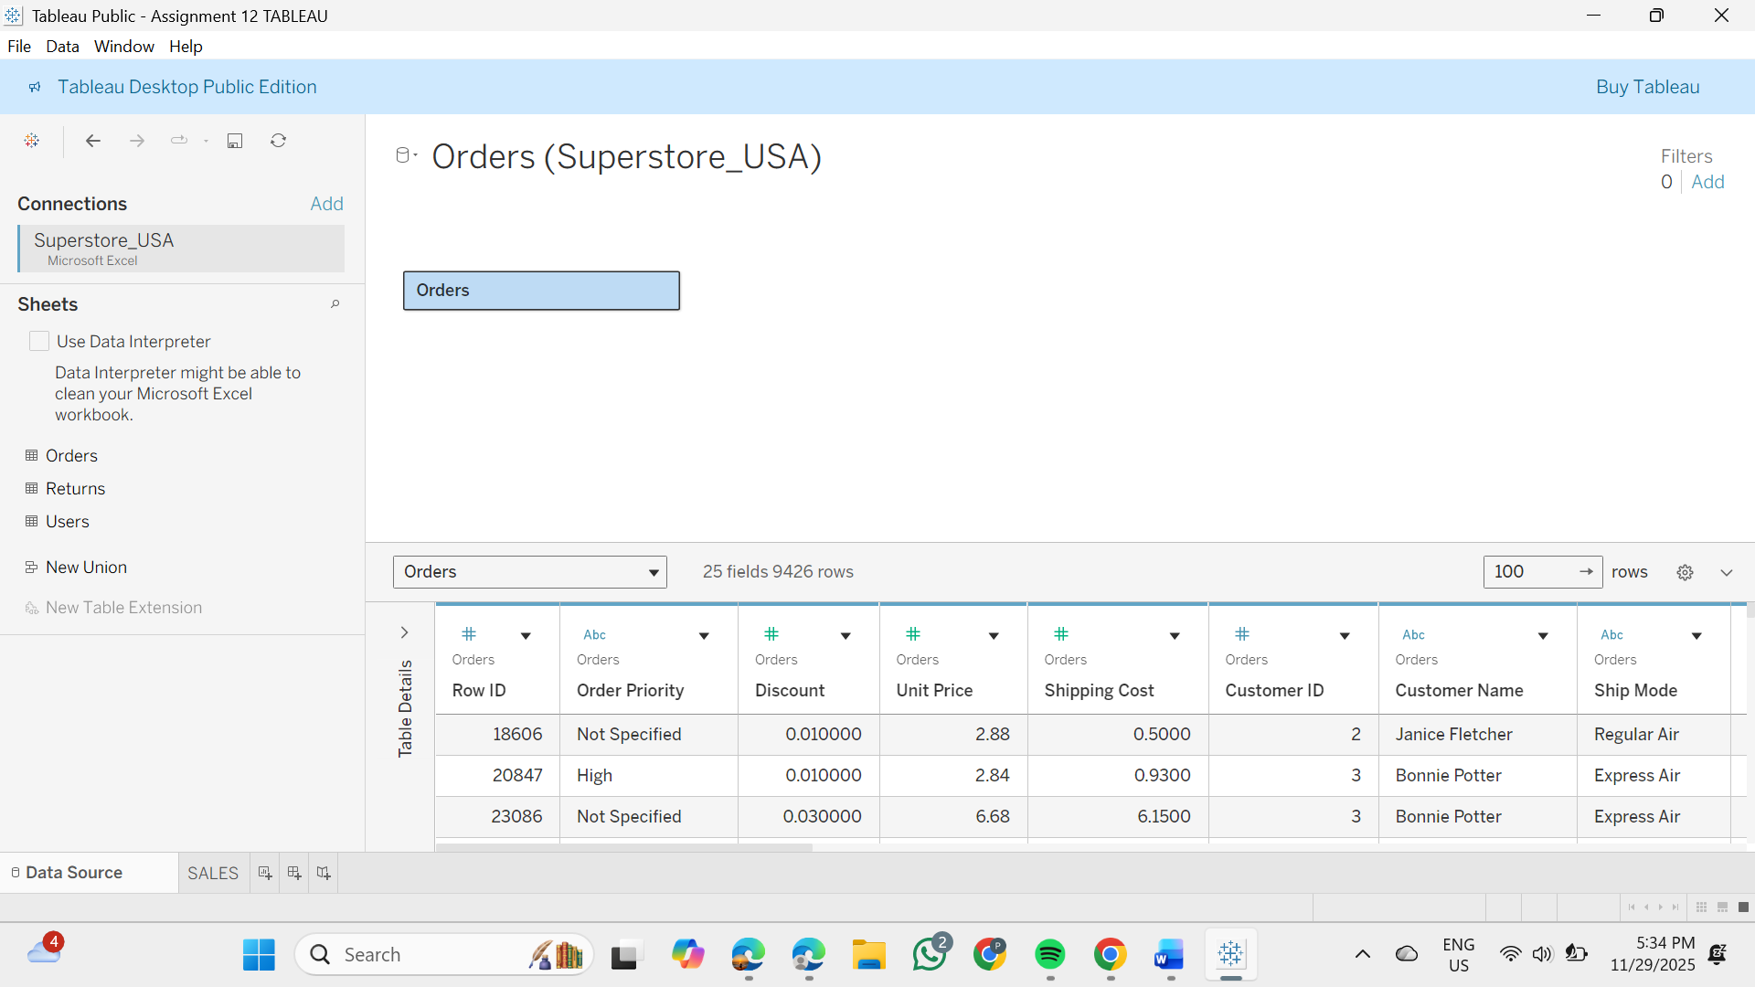
- Creating Required Calculated Field
- Created a calculated field named “Zero” 0
- Purpose: This helps position the two pie charts on the same axis to form a donut chart.
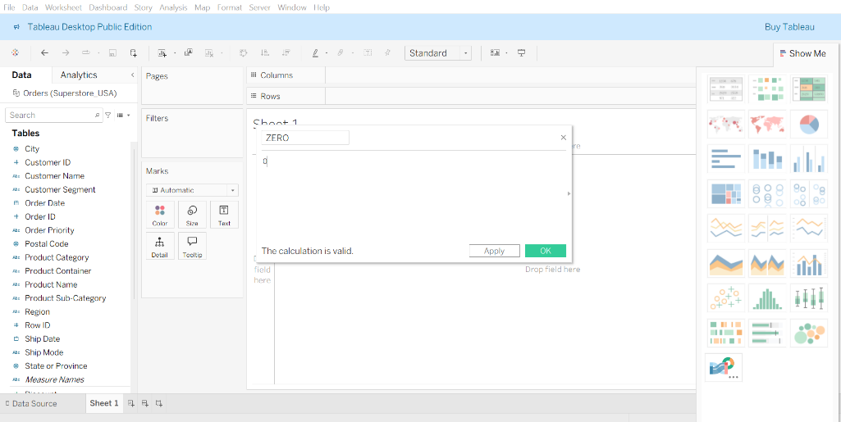
- Building the Donut Chart
- Dragged SUM(Sales) twice into Rows → Created Dual Axis
- Mark type changed to Pie for both layers.
- Outer Pie:
  - Size Increased
  - Product Category placed on Color
  - Sales added to Label
- Inner Pie:
  - Size Decreased
  - Color removed (kept White)
  - Added Text in center → Total Sales
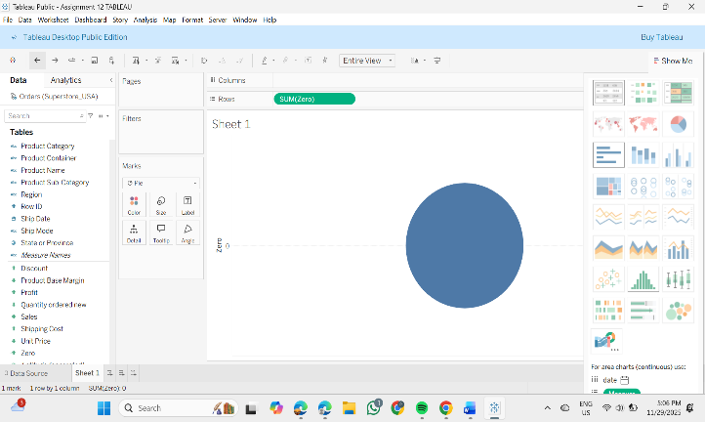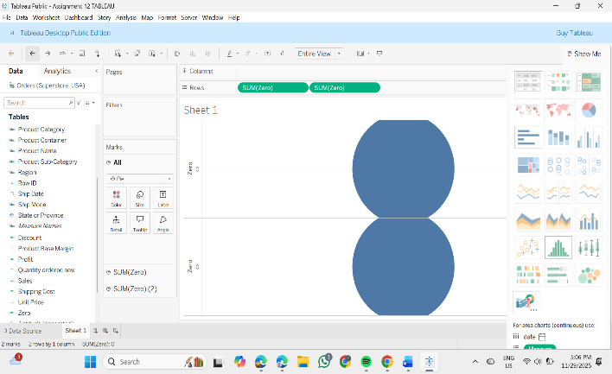
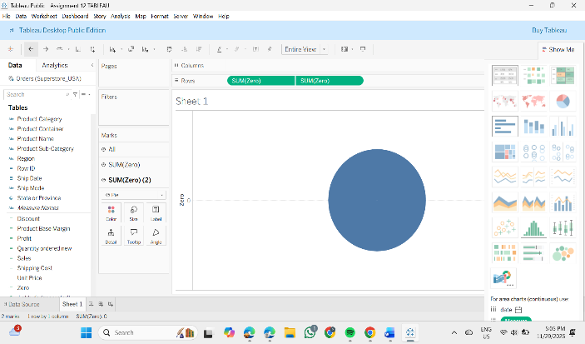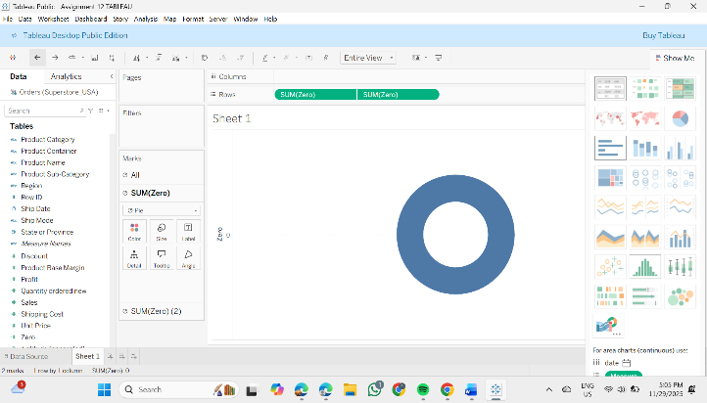
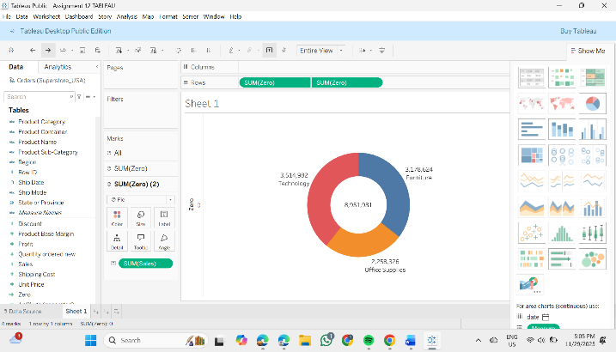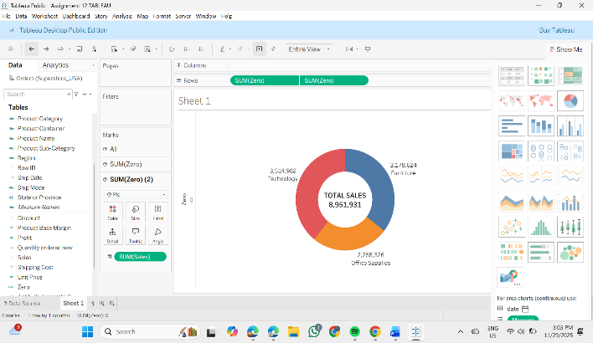
- Formatting
- Added Category labels outside the slices for clear readability.
- Customized font sizes and themes.
- Applied background color to visual.
- Labeled center as:
- TOTAL SALES
- 8,951,931
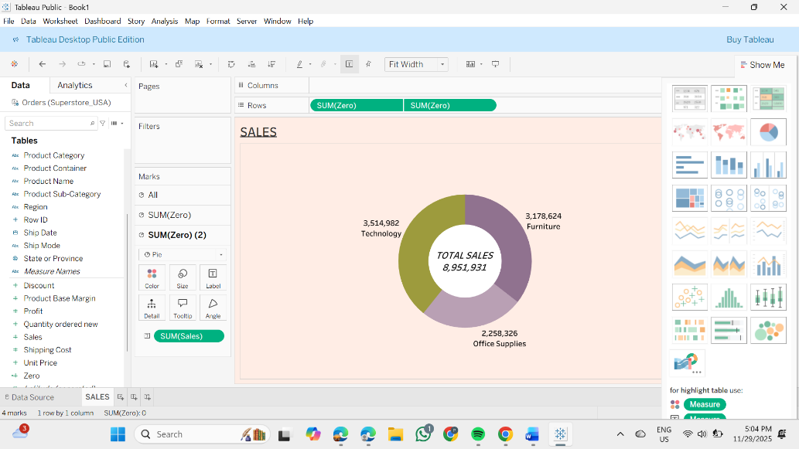
Conclusion:
Technology products generate the maximum revenue, followed by Furniture and Office Supplies.
Business decisions can focus on growing Furniture & Office Supply segments to balance category performance.
Result:
Successfully created a Donut Chart that clearly highlights each category’s share and also presents the Grand Total Sales in the center.
